DOT NET Framework
This is important for you as a dot net developer to know the history and evolution of the DOT NET Framework. Here, we will discuss what was there before the DotNet Framework and what problems we face in that and how we overcome all those problems in DOT NET Framework.
Before DOT NET Framework COM is there. So, let us first discuss what is COM and what problems we face in COM.
What is COM?
COM stands for Component Object Model. The COM is one of Microsoft Technologies. Using this technology we can develop windows applications as well as web applications. In earlier COM, VB is the programming language that is used to implement windows application and ASP is used to implement web applications.
What are the disadvantages of COM?
The major two disadvantages of COM is
- Incomplete object-oriented programming means it will not support all the features of OOPs.
- Platform dependent means COM applications can run on only Windows OS.
To overcome the above problems, the DOT NET Framework comes into the picture.
What .NET Represents?
NET stands for Network Enabled Technology. In .NET, dot (.) refers to object-oriented and NET refers to the internet. So the complete .NET means through object-oriented we can implement internet-based applications.
What is a Framework?
A framework is a software. Or you can say a framework is a collection of many small technologies integrated together to develop applications that can be executed anywhere.
What does the DOTNET Framework provide?
The DOTNET Framework provides two things are as follows
- BCL (Base Class Libraries)
- CLR (Common Language Runtime)
BCL
Base Class Libraries (BCL) is designed by Microsoft. Without BCL we can’t write any code in .NET. So, BCL is also known as the Building block of .NET Programs. These are installed into the machine when we installed the .NET framework. BCL contains pre-defined classes and these classes are used for the purpose of application development.
CLR
CLR stands for Common Language Runtime and it is the core component under the .NET framework which is responsible for converting the MSIL (Microsoft Intermediate Language) code into native code and then execution. 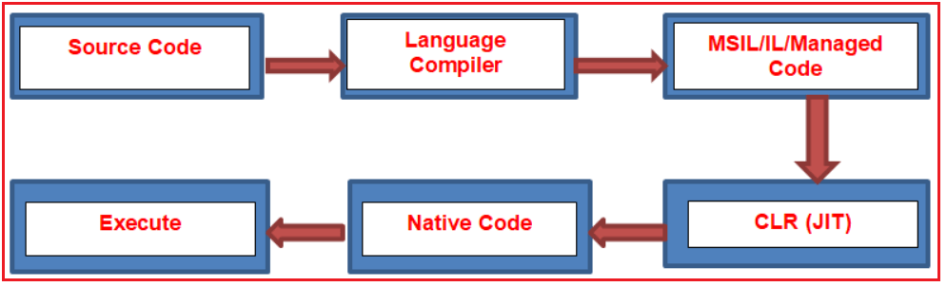
In the .NET framework, the code is compiled twice.
- In the 1st compilation, the source code is compiled by respective language compiler and generates the intermediate code which is known as MSIL (Microsoft Intermediate Language) or IL (Intermediate language code) Or Managed Code.
- In the 2nd compilation, MSIL is converted into Native code (native code means code specific to Operating system so that the code is executed by the Operating System ) using CLR.
Always 1st compilation is slow and 2nd compilation is fast.
What is JIT?
JIT stands for the Just-in-Time compiler. It is the component of CLR which is responsible for converting MSIL code into Native Code or machine code . This Native code is directly understandable by the operating system.
Different types of DOTNET Framework.
The .net framework is available in three different flavours.
- DOTNET Framework: This is the general version required to run .NET applications on Windows OS only.
- .NET mono Framework: This is required if we want to run DOT NET applications on other OS like Unix, Linux, MAC OS, etc.
- DOT NET Compact Framework: This is required to run .NET applications on other devices like mobile phones and smartphones.
- .NET is not an Operating system.
- It is not an application or package.
- .NET is not a database
- It is not an ERP application.
- .NET is not a Testing Tool.
- It is not a programming language.
What is exactly DOTNET?
.NET is a framework tool that supports many programming languages and many technologies. .NET support 60+ programming languages. In 60+ programming languages, 9 are designed by Microsoft and remaining are designed by non-Microsoft.
Microsoft designed programming languages are as follows
- VB.NET
- C#.NET
- VC++.NET
- J#.NET
- F#.NET
- Jscript.NET
- WindowsPowerShell
- Iron phyton
- Iron Ruby
Technologies supported by the .NET framework are as follows
- ASP.NET (Active Server Pages.NET) MVC and CORE
- ADO.NET (ActiveX Data Object.NET)OR ENTITY FRAMEWORK
- WCF (Windows Communication Foundation)
- WPF (Windows Presentation Foundation)
- WWF (Windows Workflow Foundation)
- AJAX (Asynchronous JavaScript and XML)
- LINQ (Language Integrated Query)
What a language is and its need?
- Language acts as the mediator between the programmer and the system.
- It offers some rules and regulations for writing the program.
- The language also offers some libraries which are required for writing the program.
What are Technology and its needs?
- Technology is always designed for a particular purpose.
- For example development of web-related applications in .NET using a technology ASP.NET.

- But the technology does not offer any specific rules for writing the programs. That’s why technology can’t be implemented individually.
- VB.NET, C#.NET both are programming languages. Using these two languages we can implement windows/desktop applications individually.
- Every language is having its own compiler
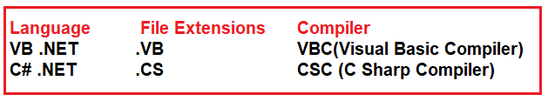

Common Language Runtime (CLR) in .NET:

How a .NET application compiled and run?
In order to understand how exactly a dot net application compiled and run, please have a look at the following image.
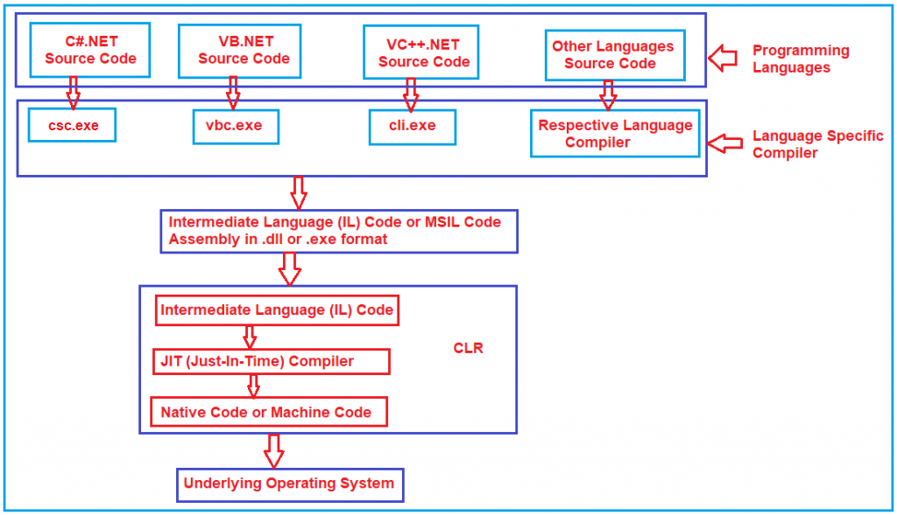
First, the developer has to write the code using any dot net supported programming languages such as C#, VB, J#, etc. Then the respective language compiler will compile the program into something called Intermediate language (IL) code. For example, if the programming language is C#, then the compiler is CSC and if the programming language is VB, then the compiler will be VBC. This Intermediate Language (IL) code is half compiled code i.e. partially compiled code and cannot be executed directly by the operating system. So, when you want to execute this IL code on your machine, the dot net framework provides something called CLR or Common Language Runtime which takes the responsibility to execute your IL Code.
The CLR takes the IL (Intermediate Language) code and gives it to something called JIT (Just-in-Time) Compiler. The JIT compiler takes the IL code and reads each and every line of the IL code and converts it to machine-specific instructions (i.e. into binary format) which can be executed by the underlying operating system.
Intermediate Language (IL) Code:
IL code is a half compiled or partially compiled or CPU independent partially compiled code.
Why Partial Compiled Code or why not fully compiled Code?
As a developer, you may be thinking about why partially compiled code or why not fully compiled code. The reason is very simple. We don’t know in what kind of environment .NET Code will run (for example, Windows XP, Windows 7, Windows 10, Windows Server, etc.). In other words, we don’t know what operating system is going to run our application; we also don’t know the CPU configuration, machine configuration, security configuration, etc. So, the IL code is partially compiled and at runtime, this IL code is compiled to machine-specific instructions using environmental properties such as OS, CPU, Machine Configuration, etc.
Common Language Runtime (CLR):
CLR is the heart of the .NET Framework and it contains the following components.
- Security Manager
- JIT Compiler
- Memory Manager
- Garbage Collector
- Exception Manager
- Common Language Specification (CLS)
- Common Type System (CTS)

Security Manager:
There are basically two components to manage security. They are as follows:
- CAS (Code Access Security)
- CV (Code Verification)
These two components are basically used to check the privileges of the current user that the user is allowed to access the assembly or not. The CLR also sees what kind of rights or what kind of authorities this code has and whether it is safe to be executed by the operating system. So, basically, these types of checks are maintained by the Security Manager.
JIT Compiler:
The JIT Compiler is responsible for Converting the MSIL code into native code that is executed by the machine. The native code is directly understandable by the system hardware. JIT compiles the code just before the execution and then saves this translation in memory.
Memory Manager:
The memory manager component allocates the necessary memory for the variables and objects that are to be used by the application.
Garbage Collector:
When a dot net application runs, lots of objects are created. At a given point in time, it is possible that we don’t need these objects. So, Garbage Collector is nothing but it is a small routine or you can say it’s a background process thread that runs and try to identify what objects are not being used currently by the application and de-allocates the memory of those objects.
Exception Manager:
The Exception Manager component of CLR redirects the processor to execute catch or finally blocks whenever an exception has occurred at runtime.
Common Type System (CTS):

The .NET Framework supports many programming languages such as C#, VB.NET, J#, etc. Every programming language has its own data types. One programming language cannot understand other programming language data types. But, there can be situations when you want to code in one language to be called in other languages. In order to ensure smooth communication between these languages, the most important thing is that they should have a common type system (CTS) which ensures that type defined in two different languages gets compiled to a common data type.
CLR will execute all programming language’s data types; this is possible because CLR will contain its own data types which are common to all programming languages.
At the time of compilation, all language-specific data types are converted into CLR’s data type. This data type system of CLR which is common to all programming languages of .NET is known as the Common Type System (CTS).
CLS (Common Language Specification):
CLS is a part of CLR. .NET supports many programming languages and every programming language has its own syntactical rules for writing the code which is known as language specification i.e. every programming language has its own language specification.
One programming language cannot understand other programming language syntactical rules (language specification). But CLR will execute all programming languages code. This is possible because CLR cannot understand any programming language specification rather CLR has its own language specification (syntactical rules) for its MSIL.
Every language compiler should follow this language specification of CLR at the time of compilation and should generate MSIL; CLR’s JIT compiler will generate native code from MSIL. This language specification of CLR is common for all programming languages code execution of .NET and is known as CLS.
For Loop Example

class Program
{
static void Main(string[] args)
{
int i, num, f;
Console.WriteLine("enter your number");
num = Convert.ToInt32(Console.ReadLine());
f = num;
for (i=num-1;i>=1;i--)
{
f = f * i;

}
Console.WriteLine("Factorial is" + f);

